# ANALYSING HOUSING PRICES IN METROPOLITAN AREAS OF INDIA

**1. INTRODUCTION**

The project, "Analysing Housing Prices in Metropolitan Areas of India with Tableau," aimed to provide a comprehensive analysis of housing prices to assist stakeholders in making informed decisions related to real estate investments, policy-making, and urban planning. Leveraging Tableau's robust analytics and visualization capabilities, the project delved into key factors influencing housing prices, identified trends, and presented actionable insights for various stakeholders.

**1.1 Overview**

***1.1.1 Objectives:***

* **Housing Price Trends:** Analyse trends in housing prices over a specified period, identifying growth patterns and fluctuations.
* **Factors Influencing Prices:** Explore key factors affecting housing prices, including location, amenities, and economic indicators.
* **Regional Disparities:** Investigate variations in housing prices across different metropolitan areas, identifying high-demand regions.
* **Predictive Modelling:** Develop predictive models to forecast future housing price trends based on historical data.

***1.1.2 Methodology:***

* **Data Collection:** Gathered comprehensive datasets from real estate agencies, government records, and publicly available housing databases.
* **Data Cleaning and Integration:** Processed and integrated diverse datasets to create a consolidated dataset suitable for analysis in Tableau.
* **Data Analysis:** Utilized Tableau's visual analytics features to derive insights, patterns, and trends related to housing prices.

***1.2 Purpose:***

Using Tableau for analysing housing prices in metropolitan areas of India can offer a comprehensive view of the real estate market, enabling stakeholders to make data-driven decisions, identify opportunities, and navigate challenges in the dynamic housing sector.

**2. PROBLEM DEFINITION & DESIGN THINKING**

***2.1 Empathy Map***

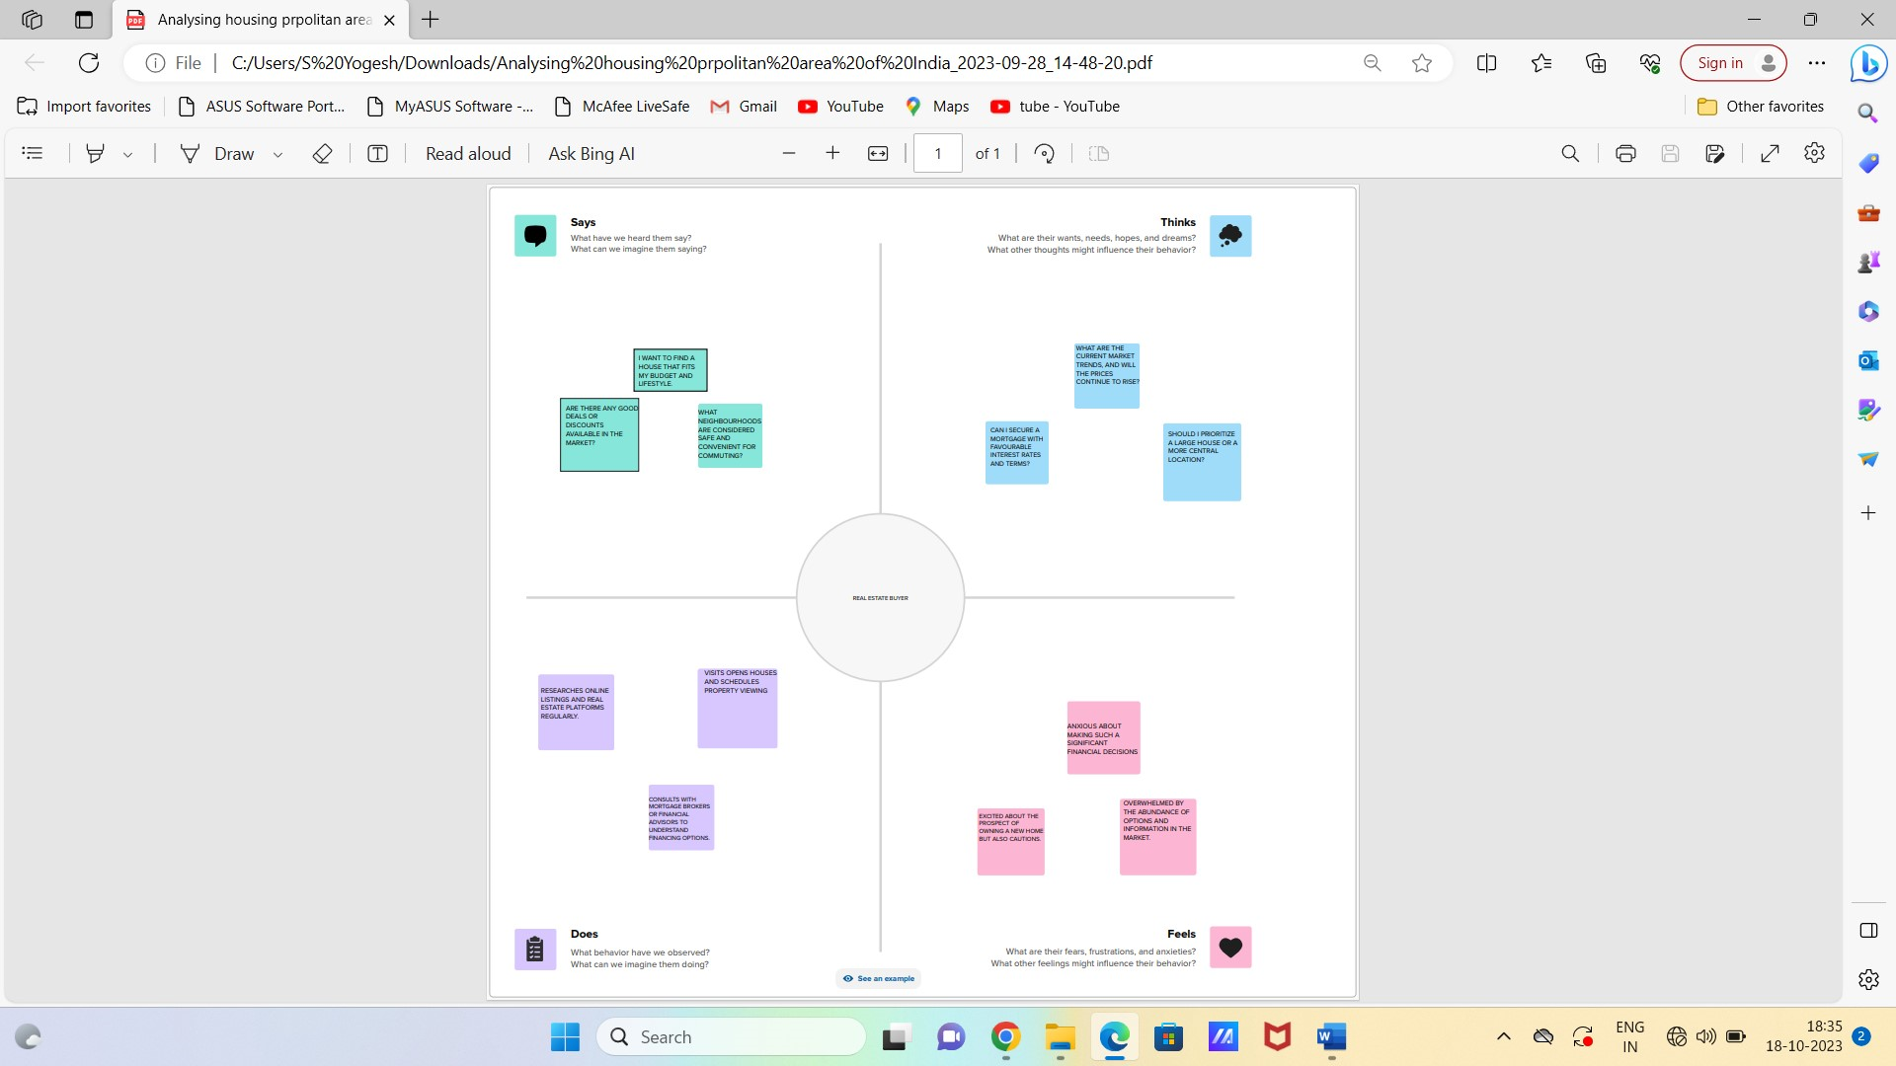

***2.2 Ideation & Brainstorming Map***

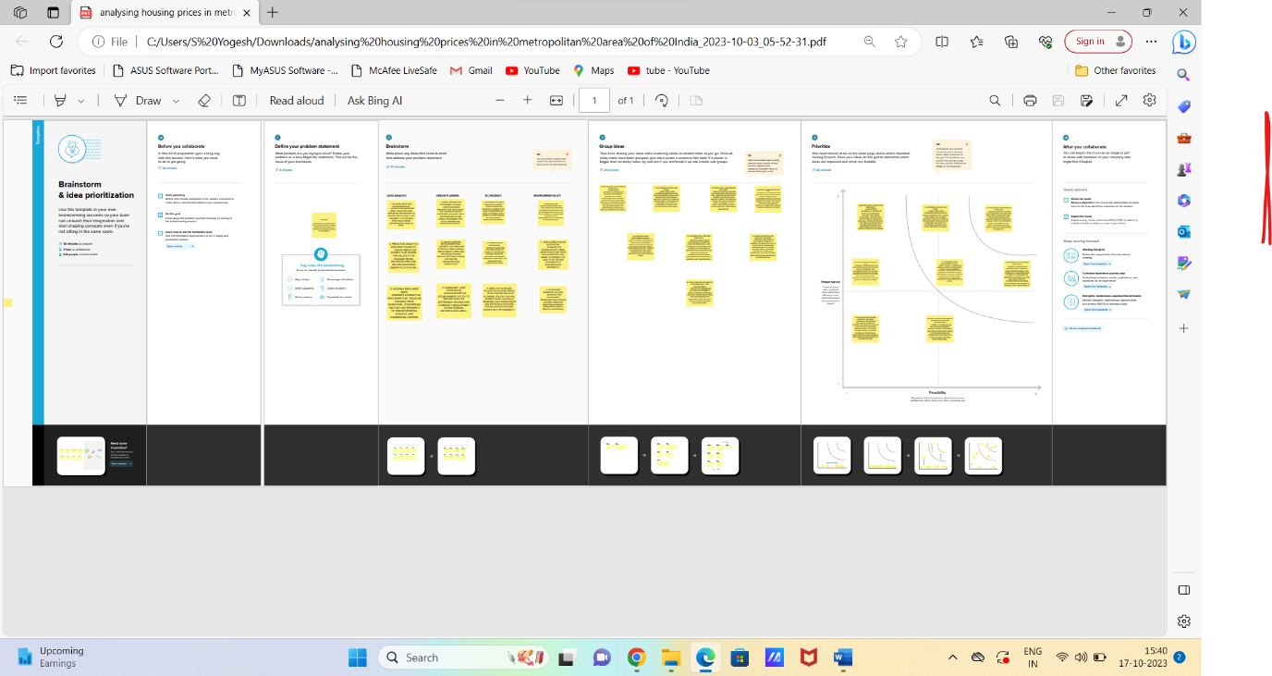

**3. RESULT**

The data preparation for visualization encompasses several essential steps. Initially, it involves the meticulous cleaning of the data to eliminate any irrelevant or missing information. Subsequently, the data undergoes transformation into a format conducive to seamless visualization. An integral part of this process is the exploration of the data to discern inherent patterns and trends. Following this, data filtering is applied to zero in on specific subsets relevant to the analysis.

***3.1 Visualizations***

The potential for crafting distinctive visual representations using a specific dataset is noteworthy. Among the array of common visualization types applicable for scrutinizing Radisson Hotels' performance and efficiency are bar charts, line charts, heat maps, scatter plots, pie charts, and maps. These visual tools serve the purpose of comparing performance, monitoring temporal changes, illustrating data distribution, highlighting variable interconnections, delineating revenue and customer demographic insights, assessing workload and resource allocation, and pinpointing hotel locations.

Map showing the houses in various metropolitan city

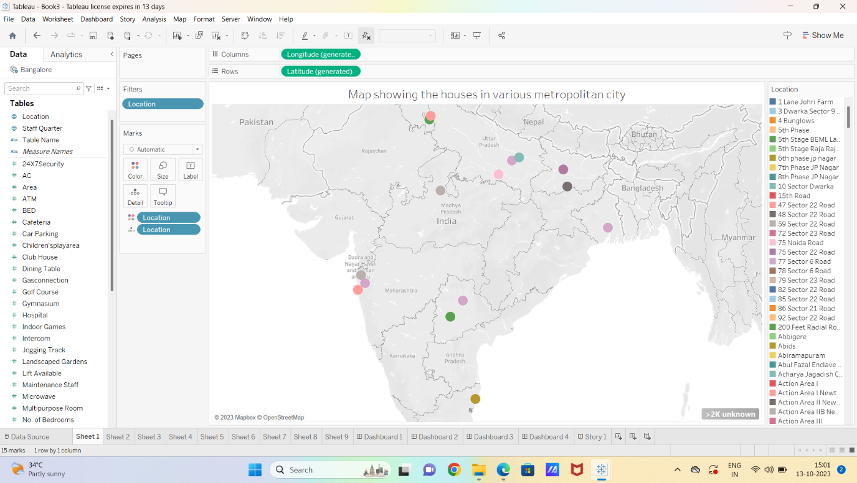Bar Graph showing prices as various locations

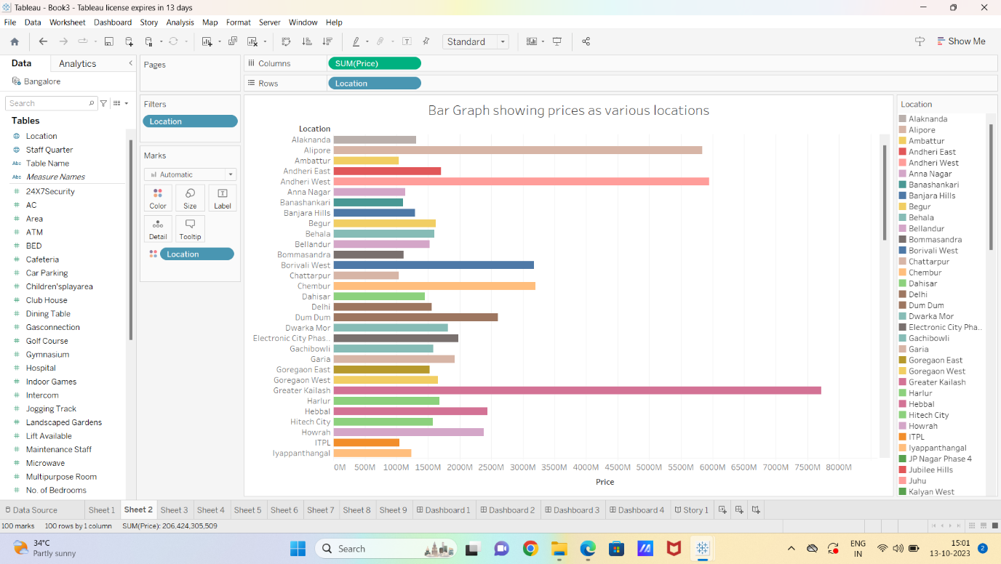

Combined line and location graph showing price and rain water harvesting

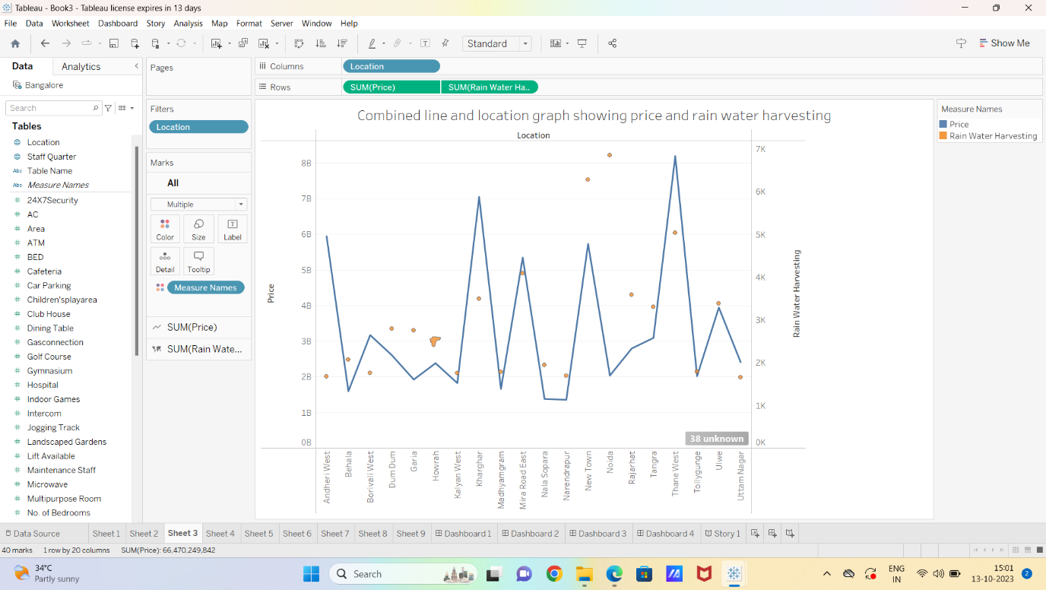

Tree Maps showing Vaastu compliant

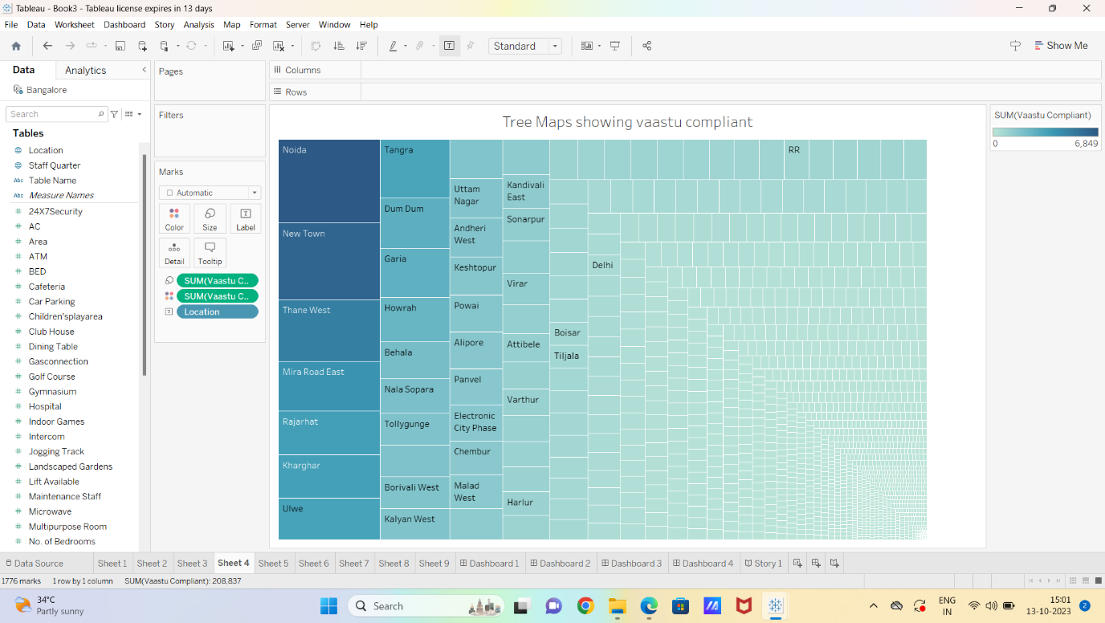

Bar graph showing location and price with no. of bedrooms

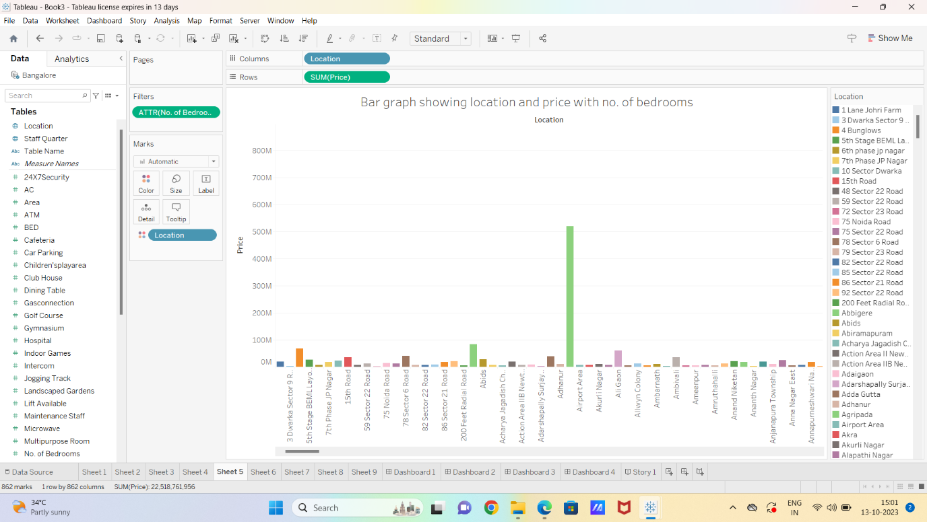

Our prices based on best facilities

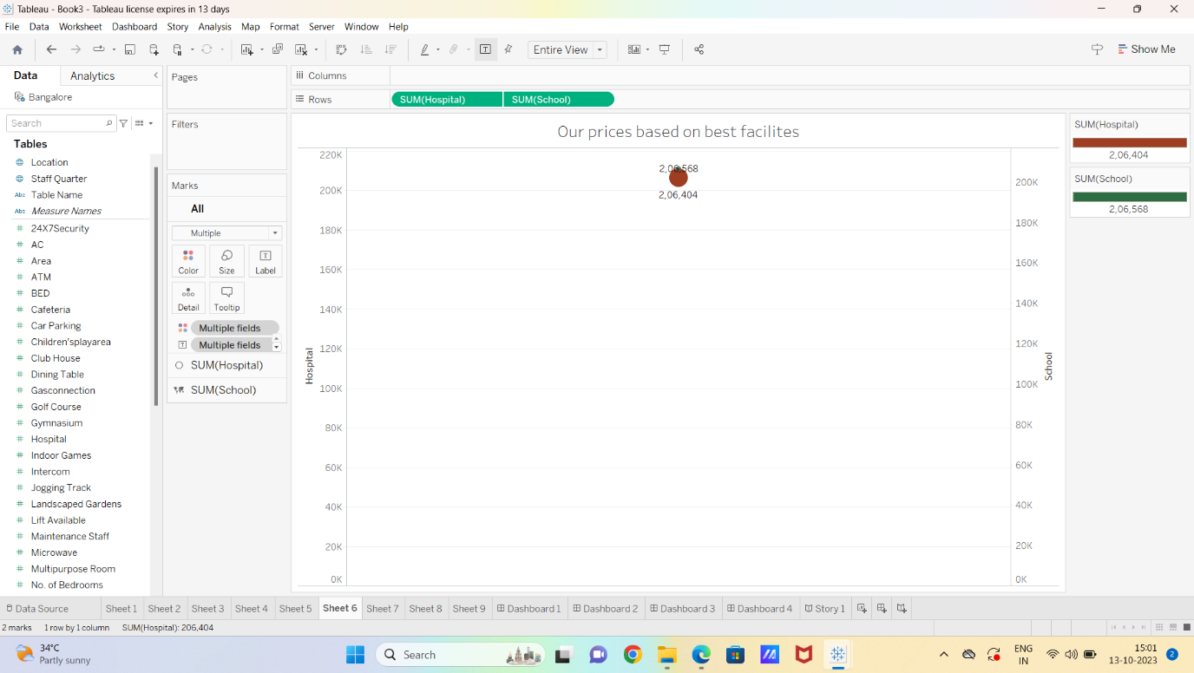

Our facilities in the best places

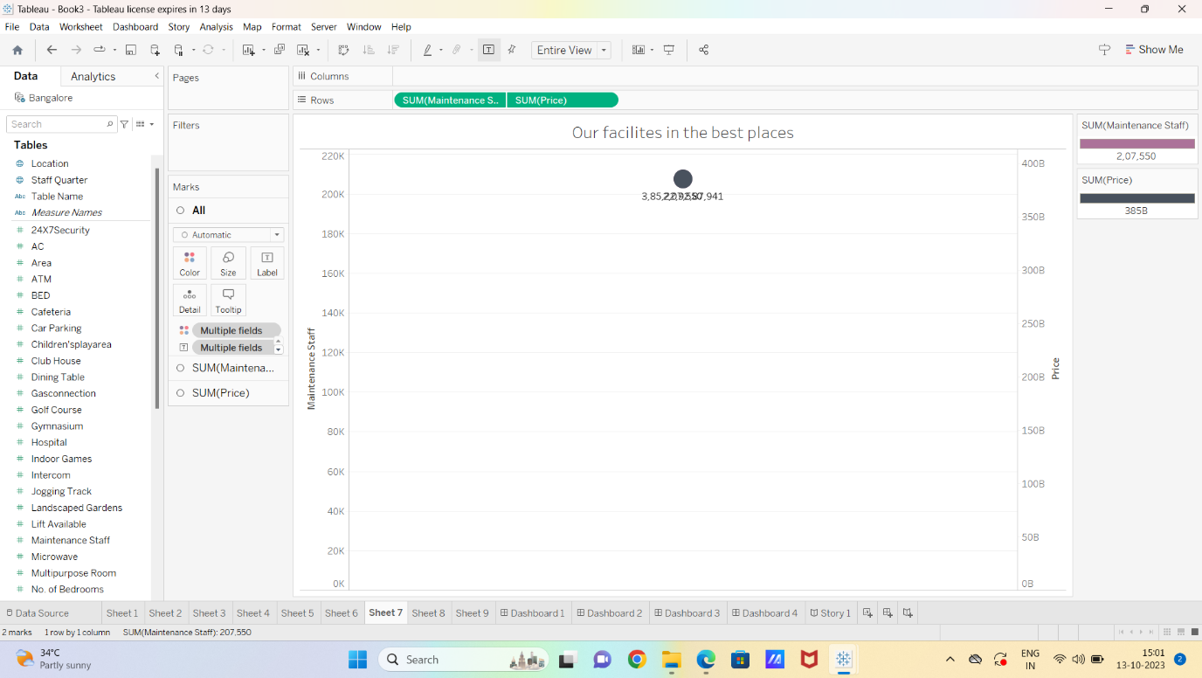

Bar comparison chart vs price and intercom facility

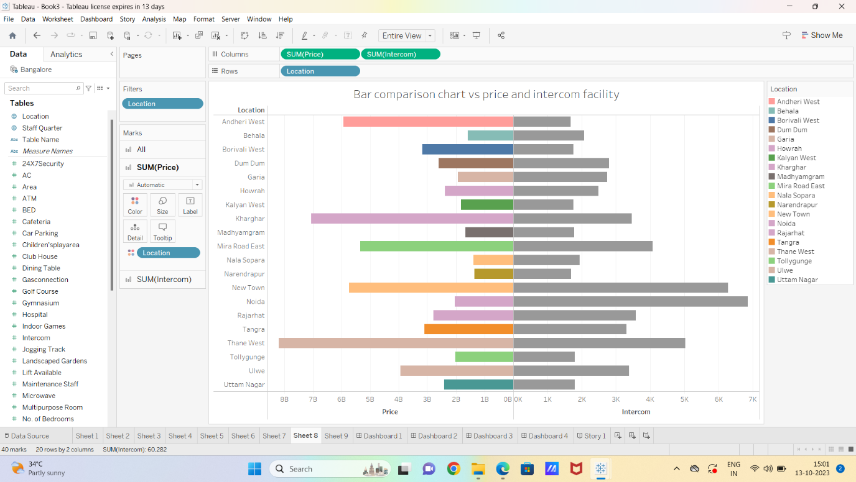

Pie chart showing various facility

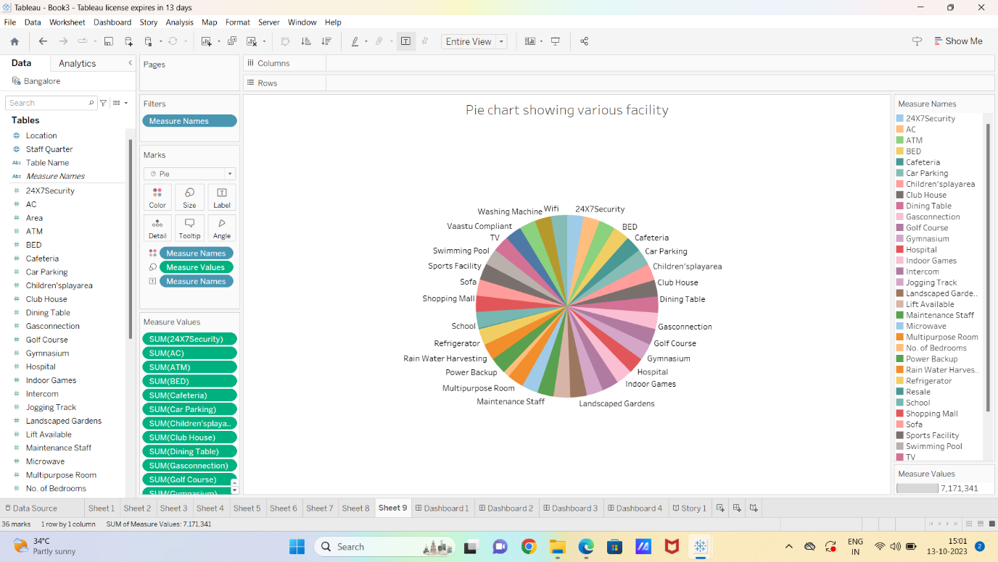

***3.2 Dashboard***

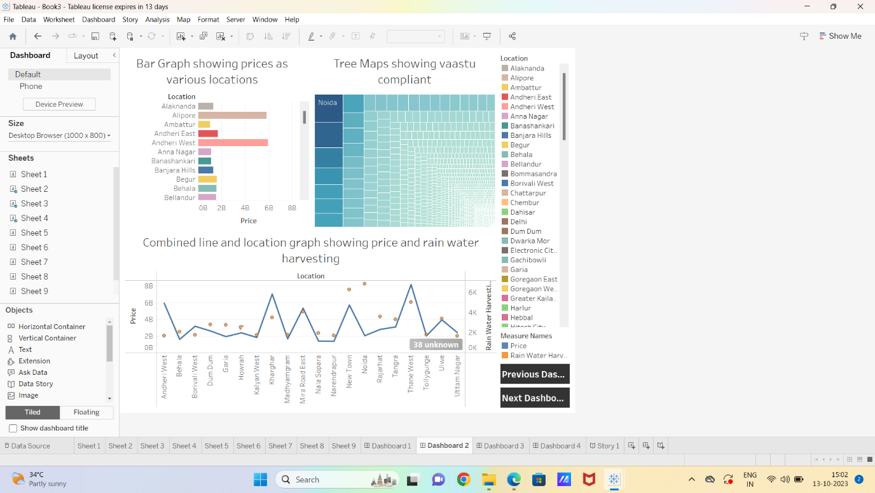

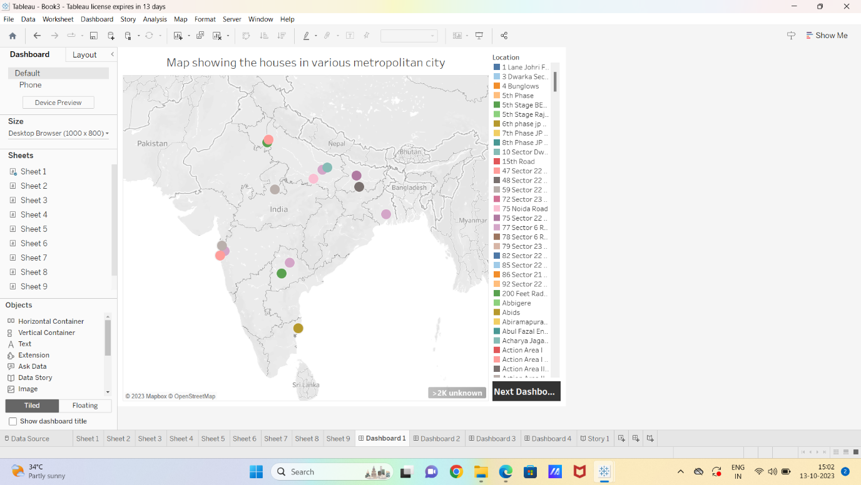

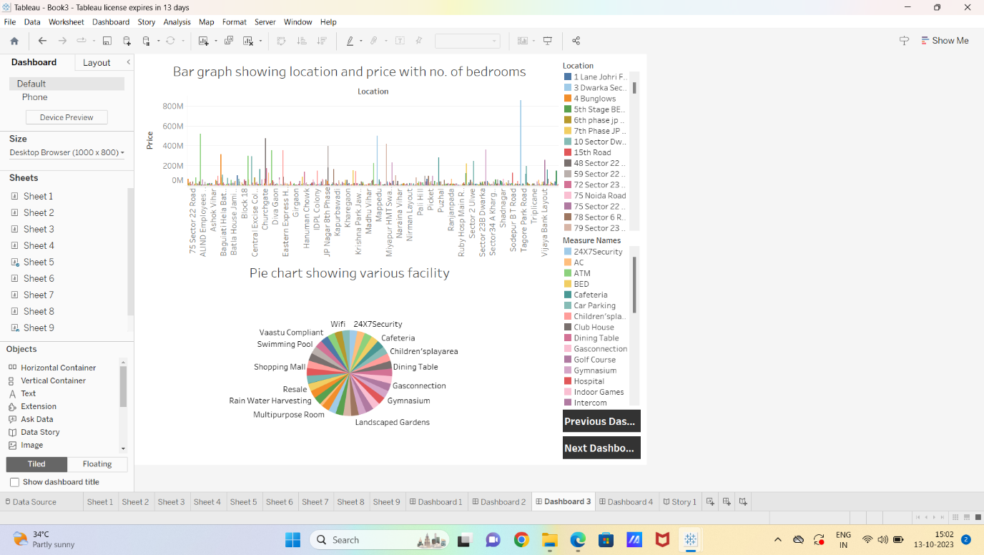

***3.3 Story***

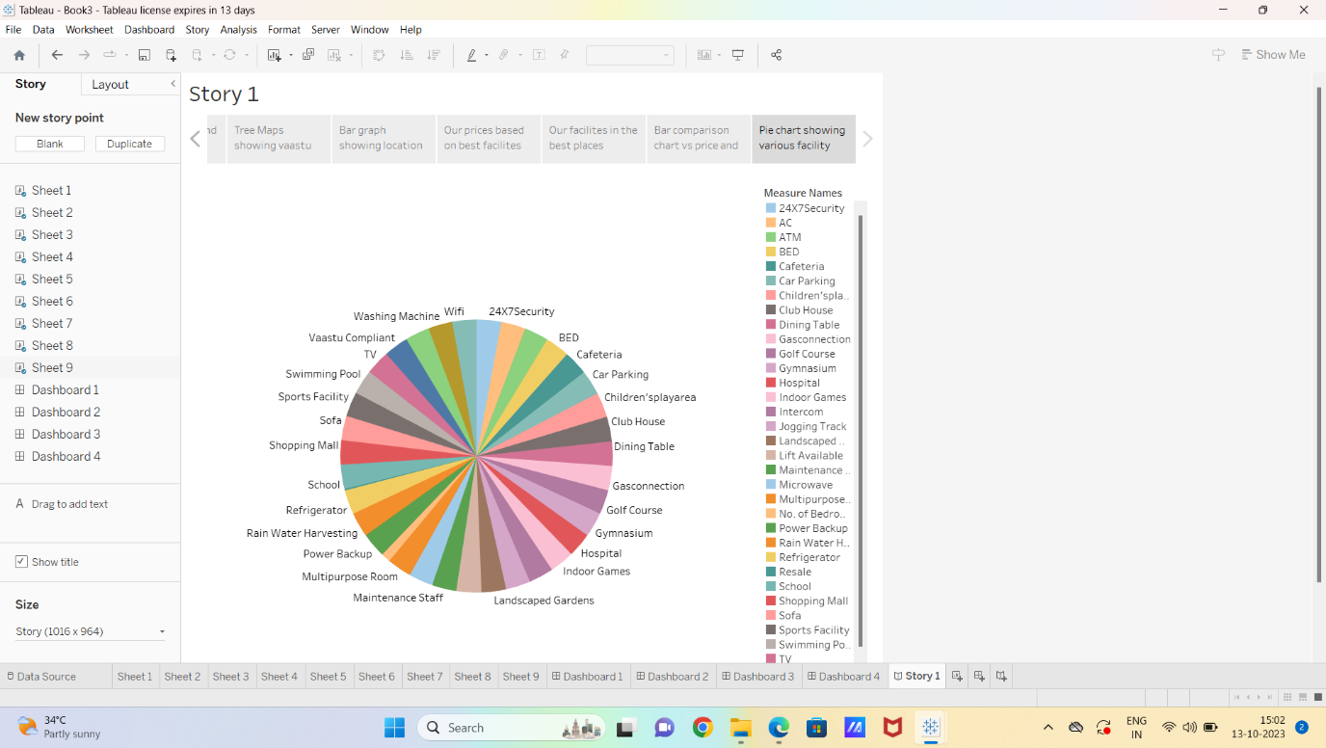

***3.4Performance Testing***

* **Amount of Data Rendered to Tableau:**

The volume of data presented in Tableau is directly influenced by the dimensions of the dataset.

* **Utilization of Data Filters:**

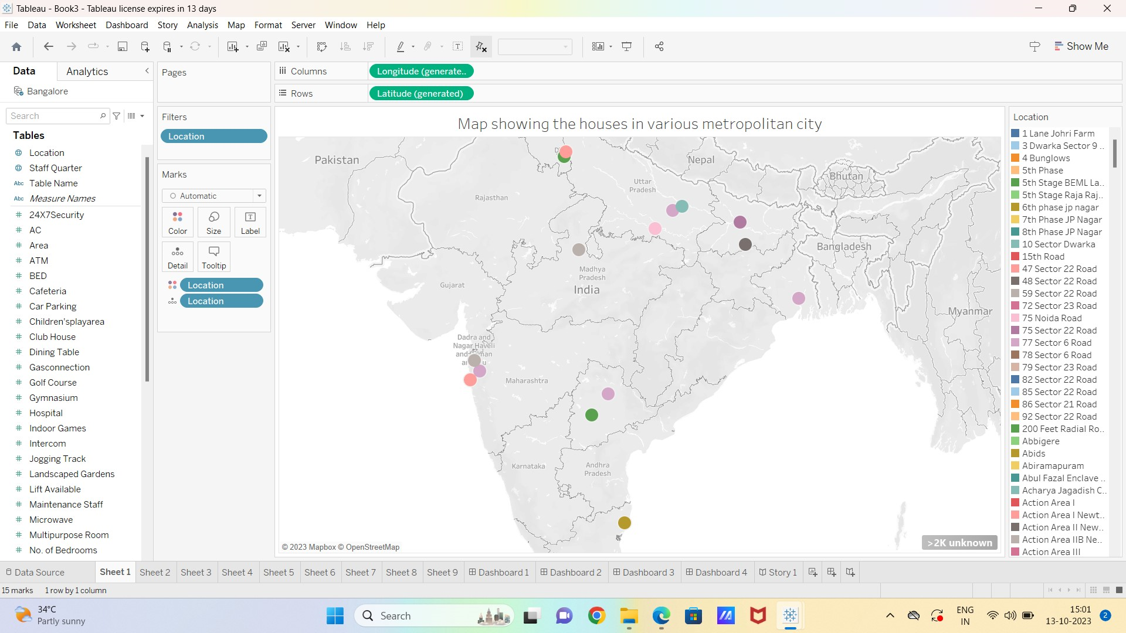

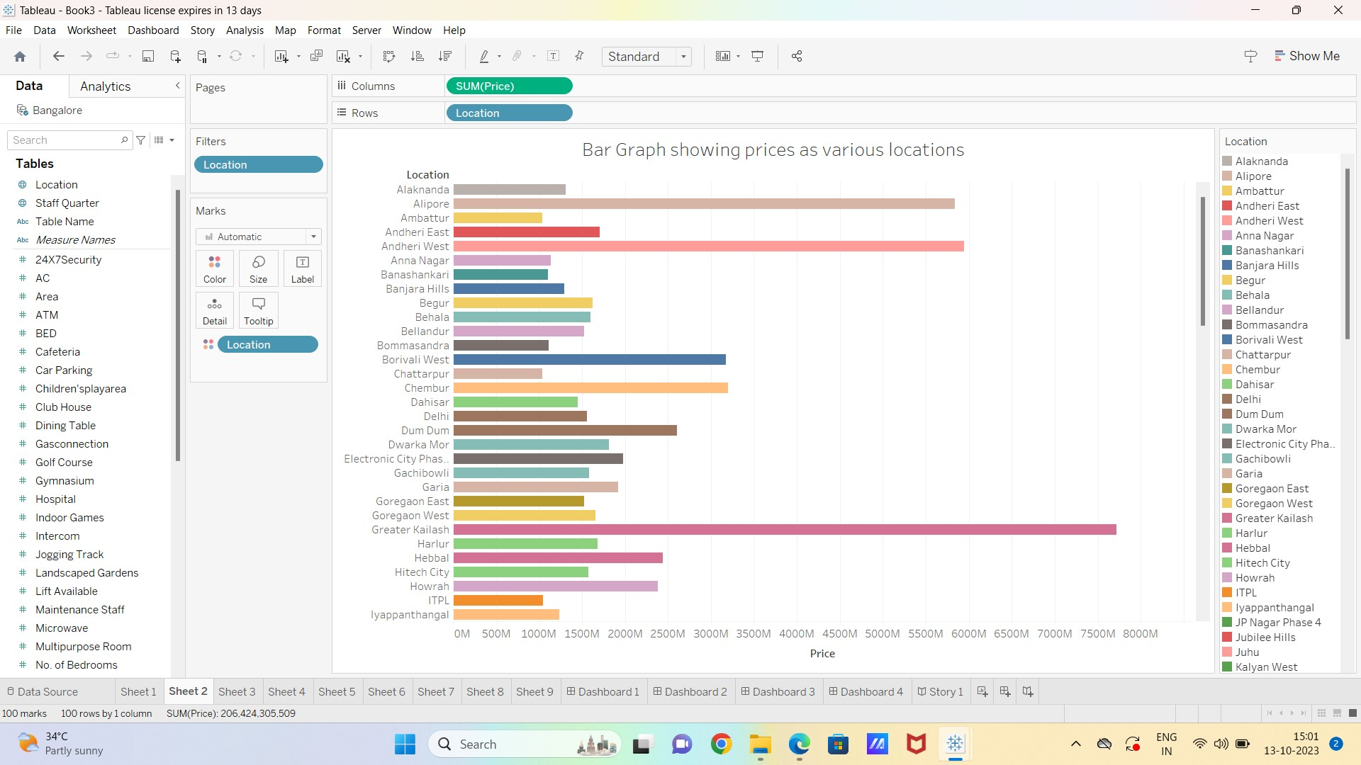

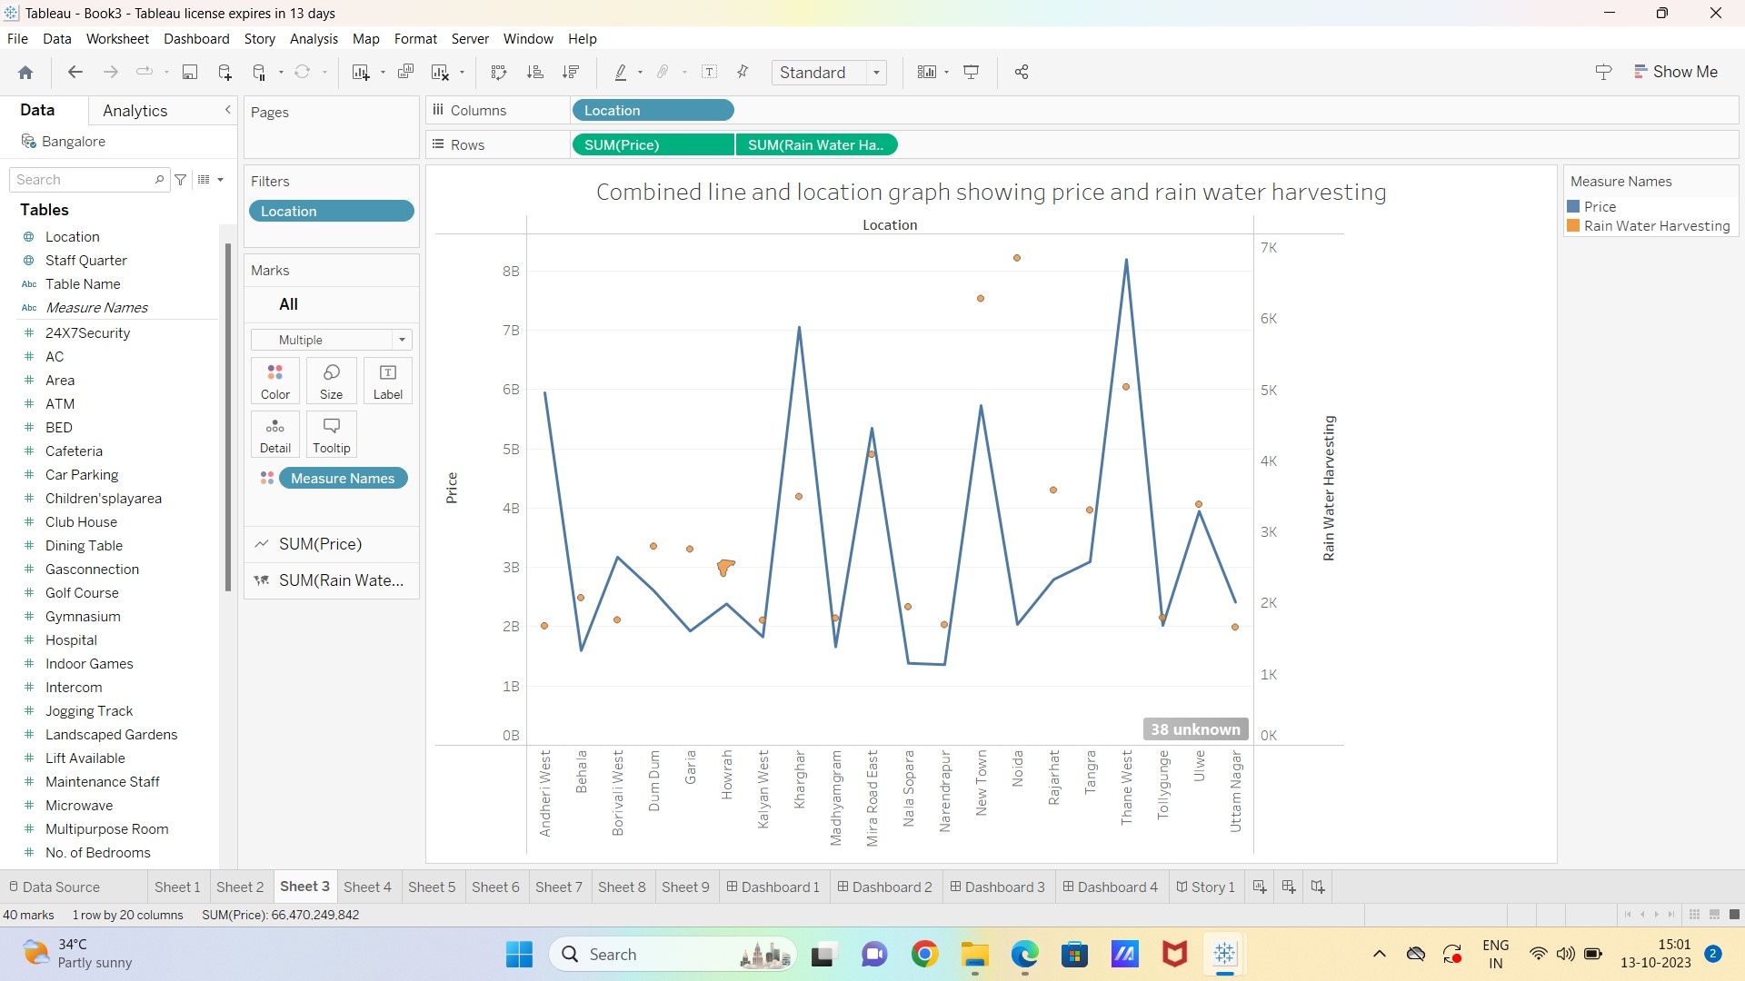

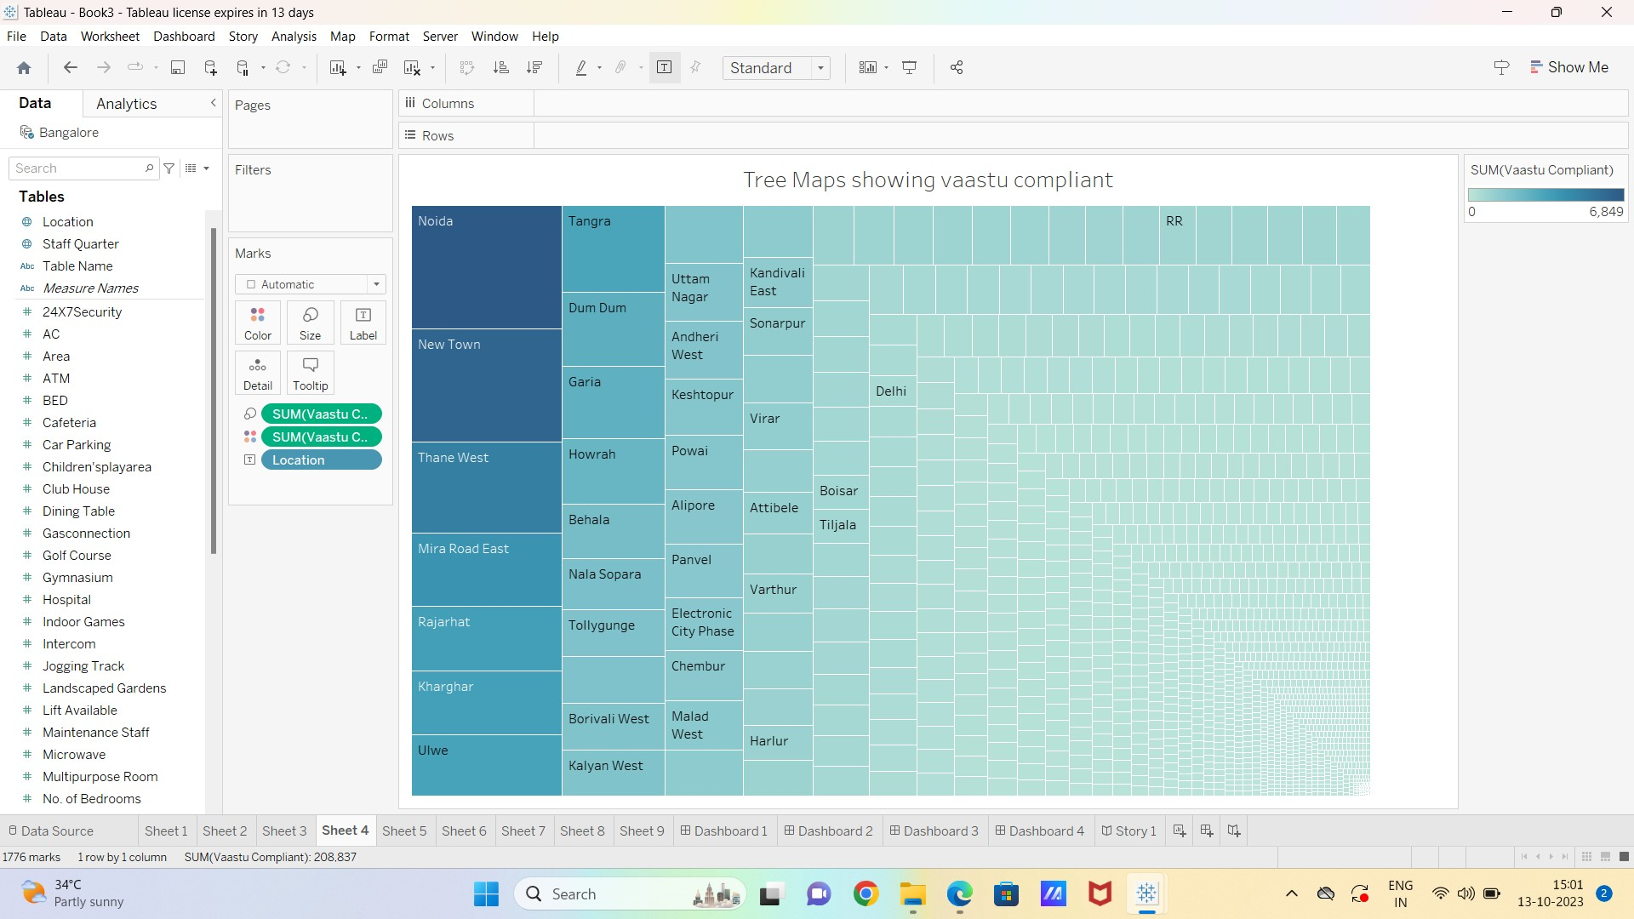

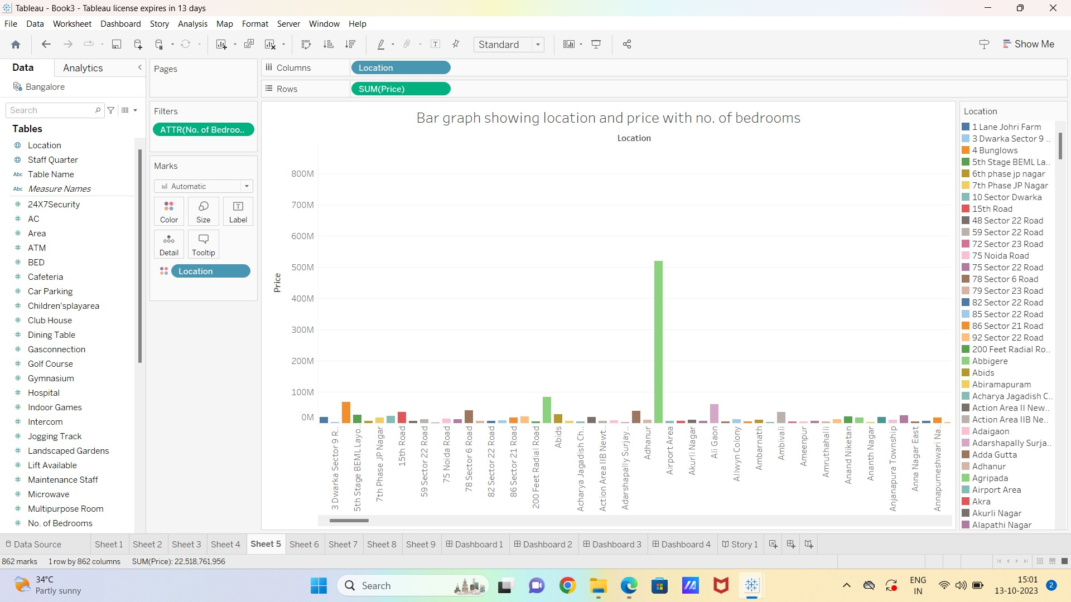

* **No of Visualizations/ Graphs:**

1. Bar Graph showing prices as various locations
2. Combined line and location graph showing price and rain water harvesting
3. Tree Maps showing Vaastu compliant
4. Bar graph showing location and price with no. of bedrooms
5. Our prices based on best facilities
6. Our facilities in the best places
7. Bar comparison chart vs price and intercom facility
8. Pie chart showing various facility

**4. ADVANTAGES & DISADVANTAGES**

***4.1 Advantages***

**Visual Clarity:** Tableau's visualizations offer a clear and intuitive understanding of complex housing price data, enhancing overall comprehension.

**Data-Driven Decision-Making:** Stakeholders can make informed decisions based on visualized housing price trends, guiding real estate investments and policy formulations.

**Interactive Exploration:** Tableau's interactive features allow users to dynamically explore and analyse housing price data, facilitating a deeper understanding.

**Holistic Overview:** Dashboards provide a holistic view of housing price trends, enabling comprehensive analysis and trend identification.

**Efficient Data Analysis:** Tableau streamlines data analysis, making it efficient and accessible to stakeholders with varying levels of technical expertise.

***4.2 Disadvantages***

**Learning Curve:** Tableau has a learning curve, and users unfamiliar with the tool may require training to fully exploit its capabilities.

**Cost of Licensing:** The cost of Tableau licensing can be a constraint, especially for organizations with limited budgets.

**Data Security Concerns:** Handling sensitive real estate data requires robust security measures to prevent unauthorized access.

**Dependency on Data Quality:** The accuracy of insights is highly dependent on the quality of input data, and inaccuracies may lead to misinterpretations.

**Resource Intensive:** Large datasets and complex visualizations may be resource-intensive, requiring robust computing infrastructure.

**5. APPLICATIONS**

* Real Estate Investment Planning
* Policy Formulation
* Market Trends for Developers
* Financial Decision-Making
* Consumer Guidance:

**6. CONCLUSION**

The project, "Analysing Housing Prices in Metropolitan Areas of India with Tableau," successfully harnessed data analytics and visualization to unravel crucial insights into the dynamics of the real estate market. The findings serve as a valuable resource for policymakers, investors, and urban planners, facilitating evidence-based decision-making in the complex landscape of housing prices.

This project highlights the transformative impact of data analytics and visualization in understanding and predicting trends in housing markets. By leveraging Tableau's capabilities, stakeholders gain access to dynamic, interactive, and visually intuitive tools that facilitate a deeper understanding of housing price dynamics, ultimately contributing to informed decision-making and sustainable urban development.

**7. FUTURE SCOPE**

The analysis of housing prices in metropolitan areas of India with Tableau offers substantial advantages but comes with considerations. The applications and future scope indicate the potential for more sophisticated and impactful use of data visualization and analytics in the real estate domain.

**8. APPENDIX**

A. **Source Code:**